UPI IN INDIA: REPORT



**VIBHORE MATHUR**

**25.10.18**

# INTRODUCTION-

Unified payment interface, commonly known as UPI, is an instant and real-time payment system which was introduced on 11 April 2016 by national payments corporation of India for safe interbank transactions. It is a type of open source facility which was given to many e-wallet applications.

# 

# BEGINNING

UPI in India was introduced on 11 April 2016, but it was a gradual progress for UPI from April-October. On 8 November 2016 pm Shri Narendra Modi announced demonetisation to kill corruption and, end black money. Denominations of 500 and 1000 were ban and the new note of 2000 was introduced, but it was hard to get cash due to lack of new currency, so to overcome this problem e-wallets which used UPI began to get in trend got popular.

ADVANTAGES OF USING UPI-

Considerably using e-wallets against cash is a great method, as it is safe, secure, and simple. Also it easily portable you have to just carry your phone and you can buy anything also some e-wallets gives you exciting offers such as cashback and some discounts like 5%,10% and more. Also, you can't only purchase from shops using e-wallets, you can also pay your

Bill, recharge your phone and many more.

DIFFICULTIES OF INCREASING E-WALLETS USE IN INDIA:

Some difficulties are as follows

* India has a literacy rate around 74.04% and some of them even don't to speak so forget about using a high configuration smartphone which is the only way to access e-wallets.
* Also, many people in India are below poverty line about 21.9% of people in India earn below rs.27 per day in rural and rs 33 for the urban area.

GROWTH OF INCREASE IN USAGE OF E-WALLETS IN INDIA:

Here is a graph which shows the number of users of UPI in India-

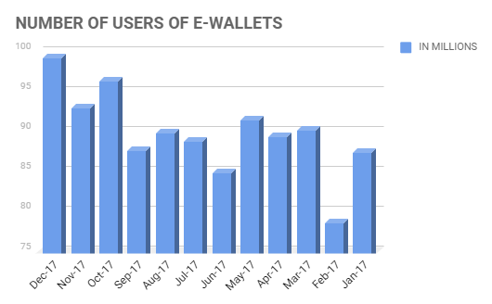

As the graph suggests that just after demonetisation UPI(e-wallets) become popular, but when cash was circulated in large quantity use of e-wallets decreased somewhat.

HOW DOES UPI WORK-

WHEN A USER FIRST STARTS USING E-WALLETS WHICH SUPPORTS UPI,HAS TO DO SOME KYC AND ENTER HIS/HER BANK ACCOUNT OR ADD MONEY TO THE WALLET BY A SIMPLE RECHARGE,THE IF THE PERSON SEND SOME AMOUNT OF MONEY FOR SAY A USER ROHAN WANTS TO SEND RS.2000 TO HIS FRIEND,SAY ROHIT THEN HE HAS TO FIRST CHECK THAT HE HAVE SUFFICIENT BALANCE i.e. Rs.2000 OR MORE IN HIS E-WALLET AND THEN HE HAS TO ENTER ROHIT'S MOBILE NUMBER AND THE JUST HE NEEDS TO TYPE THE AMOUNT i.e. 2000 AND CLICK SENDD IN THE APP THEN THE RS.2000 WOULD BE DECREASED FROM HIS ACCOUNT AND WOULD BE ADDED TO ROHIT'S ACCOUNT. THAT'S SO SIMPLE AND EASY, IS'NT IT?

FREQUENTLY ASKED QUESTION ABOUT UPI-

**Q-1) IS USING UPI IS SAFE AND SECURE?**

A-1) yes, in 2018 after cases of data leak by facebook and twitter all companies are careful about their application so it is very safe and secure.

**Q-2) IS UPI AVAILABLE FOR ME TO USE?**

A-2) yes, UPI was officially made to use for common people of the nation on April 11 2016.

**Q-3)What are the charges for using UPI?**

A-3) according to the national payment corporation of India there is a negligible fee of rs. 0.50 per transaction.

**Q-4)DO I NEED TO REGISTER FOR UPI BEFORE MAKING TRANSACTIONS?**

A-4)yes it is compulsory to register for UPI before making any kind of transactions.

**Q-5) WHICH ALL APP SUPPORTS UPI MECHANISM.**

A-5) UPI is available for the following apps-

1. Phone pe
2. Paytm
3. Bhim app
4. Mobikwik
5. Airtel payments bank
6. Google TEZ
7. Uber
8. Chiller
9. Paytm payments bank
10. Sbi pay
11. Mobile
12. Axis pay
13. Bob UPI

**Q-5) WILL I BE ABLE TO USE MY UPI ACCOUNT AFTER I CHANGE MY SIM OR MOBILE?**

A-5) In case of a change in sim/mobile/application of the PSP, the customer would require to re-register themselves for UPI.

**Q-6) AT TIME WHEN MY PHONE IS WITH OTHER PERSON, WOULD THERE BE ANY SECURITY BREACH WHILE HE TRIES TO ACCESS MY UPI?**

A-6) Yes, there would be definitely a security breach the app will ask you for your pin, password.

**Q-7) WHAT IF MY ACCOUNT IS DEBITED BUT TRANSACTION DOES NOT GO THROUGH?**

A-7) UPI provides for real-time reversals for technical declines and amount would be transferred back to the payer account immediately.

**Q-8) CAN I PUT A STOP ON MY REQUEST FOR FUNDS TRANSFER?**

A-8) Actually you can’t do this, once the payment is initialized the payment will be done at any cost.

**Q-9) What is the limit of funds transfer using UPI?**

A-9) At present, the limit of funds transfer using UPI is 1 lakh.

**Q-9) What happens if I forget my pin?**

A-9) In case a user forgets his/her pin then they have to regenerate a new pin.

**Q-10) What is the timeline to approve a collect request by a payer?**

A-10) The timeline to approve a collect request needs to be defined by the requester.

Q-**11) WHAT HAPPENS IF I ENTER A WRONG PIN DURING A TRANSACTION?**

A-11) The transaction will automatically fail.

**Q-12) CAN I LINK MORE THAN ONE BANK ACCOUNT TO ONE VIRTUAL ACCOUNT?**

A-12) Yes, several bank accounts can be linked to one virtual account.

RECENT UPGRADE IN UPI-

i) Now successor of UPI 1.0 is coming that is named as UPI 2.0 which includes more developed features and is secured.

ii) When UPI was initially launched it was only available to android phones but recently it is also available to IOS phones too.

iii) UPI continuously gets updates like initially, it was available only available for a very few apps but now it’s available to almost all app.

WHAT IS NPCI?

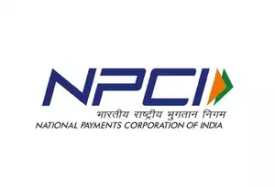

National Payments Corporation of India (NPCI), an umbrella organisation for operating retail payments and settlement systems in India, is an initiative of Reserve Bank of India (RBI) and Indian Banks’ Association (IBA) under the provisions of the Payment and Settlement Systems Act, 2007, for creating a robust Payment & Settlement Infrastructure in India.

Considering the utility nature of the objects of NPCI, it has been incorporated as a “Not for Profit” Company under the provisions of Section 25 of Companies Act 1956 (now Section 8 of Companies Act 2013), with an intention to provide infrastructure to the entire Banking system in India for physical as well as electronic payment and settlement systems.